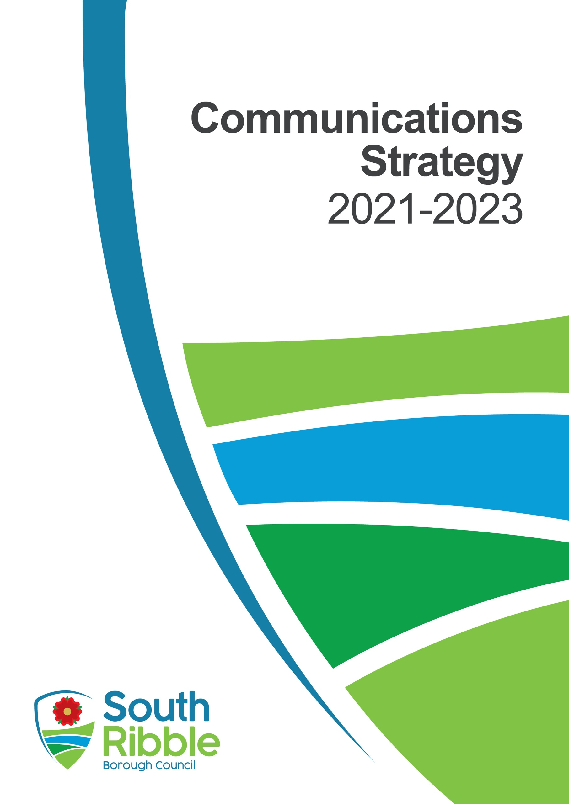

Introduction
This strategy sets out how we intend to further develop our communications with residents, colleagues and other stakeholders to ensure people are informed and satisfied with the services that we provide.
The world of communications has undergone dramatic changes over the last few years with digital and social channels meaning expectations have changed. This has been amplified during the pandemic in 2020 and it is important we take this opportunity to strengthen the relationship between residents and the council.
This document sets out how creative communications can help us serve and engage our residents better and make the council a clearly visible part of improving life in South Ribble.
Council vision and priorities
This strategy is in place to support the activities set out in the corporate strategy and achieve the vision of:
A healthy and happy community, flourishing together in a safer and fairer borough that is led by a council recognised for being innovative, financially sustainable and accountable.
The communications team is responsible for promoting these priorities and values in a clear, concise and effective way to all stakeholders in a bid to maintain and build the reputation of the council across all communication and engagement platforms.
This communications strategy sets out a framework underpinned by clear actions which will ensure that, going forward, the council will continue to have a robust, strategic approach to communication and engagement aligned to its corporate priorities.
Where we are
The council has undergone a huge amount of change and instability over the last few years with a changing administration and significant changes to the senior management. While the council continues to deliver good services for residents some of the governance arrangements have been criticised and this has inevitably had an impact on the reputation.

A lot of these problems have been legacy issues that are being resolved and so the authority is now able to look towards a bright future with a new corporate strategy, an ambitious programme of work and a new brand that will be key to the implementation of this strategy and improving people’s perceptions of the authority and their ability to access services.
We have a newly-created team sharing a service with Chorley Council that will provide extra resilience for us to deliver the aims and objectives in this strategy.
In 2019, the staff survey communications responses were:
- I have regular team briefings 75%
- Relevant information reaches me in a timely manner 60%
- Overall communication is good 50%
- The formal communication channels are effective 54%
- There is effective two-way communication between services 40%
For the majority of these scores there is roughly 25% for each where staff neither agree or disagree outlining scope to change that viewpoint to be more positive or signifies that a group of people are not interested in receiving information.
Externally, the results from the most recent resident survey said:
- 67% of residents are satisfied at how the council runs things
- 46% feel the council offers value for money
- 51% feel they are well informed, with 35% saying they are not very well informed
While these figures are reasonable when benchmarked against other local authorities there is scope for improvement.
The most recent team review in 2020 highlighted the following three areas as key to improvement:
- Ensure communications activity is properly planned and evaluated
- Making the most of digital communications channels
- Focussing more on internal communications to ensure staff are informed and understand how they can play their part in the organisation achieving its goals

Our Communications Principles
- The council is a listening organisation – we take the views of residents, businesses, employees, partners and stakeholders into account when developing plans and tackling challenges.

- The council, its staff and elected members are open and honest about the council’s work.

- The council will celebrate success, own its challenges and help to enhance the sense of pride across South Ribble.

- The council will tailor communications to its audiences and invest in and make best use of innovations in technology to communicate more effectively and drive down costs.

Our Aims
- To rebuild our reputation as a community leader that delivers improvements for residents and businesses

- Position the council as a forward thinking and innovative local authority that is seen as an exemplar among its peers

- Promote South Ribble as a great place to live, work, invest and visit

- Support local communities to work together to improve their neighbourhoods

- Promote and encourage healthy and environmentally aware lifestyles.

Our Objectives
- To use a consistent style and approach to two-way communication that is authentic and customer friendly.

- To make sure corporate priorities are well-communicated and understood by residents, businesses, staff, partners and stakeholders.

- To have communications which are targeted to relevant audiences (taking into account the different needs of the borough’s diverse communities) and driven by research to ensure the right communications are delivered at the right time, in the right way, to the right people.

- To listen, act on and give feedback to residents, businesses, employees and partners.

- To deliver cost-effective and innovative forward-thinking campaigns which are planned, executed well and monitored successfully.

- To develop South Ribble’s new brand and ensure it is applied consistently across the borough in a way that reflects our professional approach as a local authority.
Our Audiences
Our residents
- We want residents to be involved in developing priorities and in shaping services that meet their needs. We also want to ensure that we keep them informed about services, and how they can be accessed, including any changes, key successes and challenges facing the council and the wider borough.
Our employees, including trade unions
- The council employs around 300 full-time equivalent staff and many are also residents. Staff are ambassadors for the council and its services and we need to make sure they are kept informed in a timely way. The council wants to sure that staff are motivated and supported, focused on council priorities and are effectively engaged in all communications and improvement activity.
Our councillors
- Councillors have a significant role to play in effective communication and engagement. They are ambassadors for the council, dealing with residents, businesses, partners and other stakeholders on a regular basis and having opportunities to promote the council and its work regionally and nationally through their political networks.
People working in and visiting South Ribble
- We want the people who visit our borough to have a positive experience and to tell others about life in South Ribble. The South Ribble ‘brand’ and how we promote this can be positively developed through visitor experiences.
Existing businesses in South Ribble, potential businesses who may relocate or invest in South Ribble, business and economic development and regeneration partnerships and organisations and developers
- The borough has a diverse mix of businesses and we are working with them to encourage more businesses to locate here and developers to invest in the borough. We will use our communication and engagement tools to support and encourage businesses and potential developers and investors to be advocates for the area.
Stakeholders and partners, including voluntary and community groups, parish councils, Lancashire County Council, neighbouring district and borough councils
- Services are provided in the borough by a wide range of service providers, including other public sector agencies and voluntary, community and faith groups. The council wants all its stakeholders, including partners and the local media to be advocates for the council and we will use our communication and engagement tools to support them to do this.
Local Members of Parliament
- The MPs for South Ribble and the Ribble Valley are key stakeholders with whom we will share relevant updates and news about the council and its services. We want to make sure they understand the role and services provided by the council.
Central Government
- The council’s reputation with central government and its departments is crucial to its success. Local councils also work closely with Central Government on national awareness and behavioural change campaigns e.g. Preparations for Brexit.
Local, regional, national and trade media
- Our media relations are vital to meet the aims and objectives of this strategy. We will share press releases and conduct press briefings and photo opportunities to ensure that our messages reach the appropriate media channels for our desired audiences. Good media relationships can enhance this and ensure a greater reach for our content.
What will be different
The media landscape is changing rapidly with many traditional outlets now operating in completely different ways following the pandemic. The 2020 Ofcom Communications Market Report outlines some key themes that will considered as part of this strategy:
- While used by the majority the internet is not evenly distributed – 13% refuse to use it and that hasn’t changed for three years

- Those who do use the internet use it extensively – 3 hours 29 minutes on average per day:
  - 18-24-year-olds connected for five hours per day
  - 25-34-year-olds connected for 3.5-4 hours per day
  - 45-54-year-olds connected for 3.75 hours per day
  - 55+ connected for 3 hours+ per day
- Social media is used extensively across all age groups – 72% of people aged 18+ use it
- The top five channels are:
  - Facebook 43.9M users
  - YouTube 43.4M users
  - Messenger 43.4M users
  - WhatsApp 30.2M users – this is the channel that is growing most as a main channel
  - Instagram 28.2M users
- Radio remains flat at 89.8% of adults listening to it
- We’re watching more video and less telly
- News sites attract more visits than gov.uk sites – even during the pandemic. While newspaper circulation is falling – media consumption across all platforms is increasing.
- ‘Dark social’ channels WhatsApp and Messenger are being used significantly more – by 40% of people on a daily basis
- Hyper local site NextDoor is now being used by 4M people and a new entry to the charts
Using this data and actions from the team service review in 2020 the strategy will have four main themes:
- Doing digital better to engage with our residents
There is work to do to improve our digital communications presence to ensure we use it is an effective two-way engagement tool with residents. The approach is currently inconsistent and in the resident survey feedback suggested its use could be better. There are many emerging channels and trends that we need to capitalise on so a full review of our approach to digital channels will be undertaken. While not directly related this will be significantly enhanced by the launch of the new corporate website in January 2021 and the launch of the new brand:
- Gain a better understanding of the social channels available and how we can use them better – this will focus on platforms such as WhatsApp, Messenger and NextDoor and will need to be part of the customer service review and work alongside the new digital strategy
- An audit of all groups and forums in the borough to establish who the ‘gatekeepers’ are

- A consistent and data-led approach to sharing information so we are targeting the right people in the right place
- A continual cycle of review so we can focus on methods that work and our time is more efficiently spent

- Planning for the future
The majority of our work is reactive and ad hoc in nature and we need to work harder with colleagues to ensure an 80/20 planned approach where possible. Without this we will not improve our efficiency and the objectives we have set will not be achieved. A programme of communications plans must be created as part of the business planning process and be evaluated regularly to ensure their effectiveness. The team has been reviewed to help this work better and this cuts across everything we will do.
- Importance of internal
We always look to ensure that colleagues and members are informed of what’s happening but as technology has evolved our channels for communicating haven’t necessarily kept up. Added to that there is more focus on external communications and the new shared service with South Ribble will add the resilience to enable us to prioritise internal communications better. This will need a refresh of the internal communications strategy.
- Rebranding South Ribble Borough Council as a modern, professional authority
A new logo has been agreed to launch in line with this strategy at the start of 2021. The authority has suffered from legacy issues over the last few years and while it is viewed as providing good services by residents much work needs to be done to enhance our reputation and tell people our story. To do that successfully we need to implement the new brand in a consistent way and ensure everything we do or produce externally looks professional and fits with our new image.
Monitoring and evaluation
We will use results of resident and staff surveys to measure if the strategy is achieving its aims but just as importantly it will be the evaluation and success of the individual communication plans, which will determine how we are progressing.
A monthly report will be brought to senior management to update on the progress of communication plans.
Given the changing nature of communications this strategy will run for two years with a review after 12 months to ensure it is still fit for purpose.

Action plan
Priority | Actions | Rationale | Timescales | Costs/ Savings | Implications (e.g. resource, risks)
Short-term
Launch Communications strategy | Inform colleagues of the new strategy | An opportunity to refresh teams about the role of communications and introduce the new shared service. It will include a new ‘seven steps to successful communications that will be developed to aid this process. | January 2021 |  | We will require time to do this and work with teams to understand the best way to do it.
Refresh the Internal communications strategy | To review internal communications channels | To look at how we can take advantage of new technology and changing working practices during Covid-19 to better communicate with colleagues and councillors. It will build on the previous strategy, which had the right concepts but not the resilience to deliver | February 2021 |  | This will need some dedicate resource in part and that will be possible due to the new team structure. This will lead to several new actions once the strategy is drafted.
Development of campaigns planner | To embed this as a way of working | This is to ensure as much activity as possible is planned and evaluated effectively on an 80/20 basis accounting for the fact there will always be some unplanned work. | December 2020 |  | The team has been restructured to make this work better but where additional projects come in we can use external resource as required as long as it is factored into project budgets.
Launch of new brand | To prepare and implement this in a coordinated way | With the new logo agreed we now need to ensure it is rolled out in a planned way. | January 2021 | Up to £20,000 identified if required | It will be done on a ‘replacement only’ basis with digital channels being the first to switch over in line with the website launch.
Digital channels review | To review our approach to how we utilise channels such as social media, emails etc. | The review identified this as an area for improvement and we need to review current practices and how we can improve our use of these as well as upskill the team. This will be a detailed piece of work and will cut across the customer services team and digital strategy. | March 2021 |  | The findings may lead to the need for additional training and it will be important we use the most effective channel for each project we are working on.
Audit of existing communication channels | To ensure we have an overview of all the channels available to us. | We continue to see more and more community magazines pop up and not everyone is online so we need to ensure we know what method is most effective in each part of the borough. This will tie in with the digital channels review. | February 2021
New website launch | To ensure it is promoted and fits with our communications aims | A better website will hopefully reduce the number of service requests handled through social media and will be an easier way for people to find information and for us to promote what is happening. | January 2021 |  | This is predominantly being delivered outside of the team but this strategy will be help achieve its success.
Medium/Longer Term
Skills review | Agree areas for development in the team to meet the new challenges | Linked in to the item above we need to ensure the team has the skills to deliver the new way of working and each member of the team will consider what development is required as part of the performance review process. | May 2021 |  | Will be dependent on what funding can be provided for training and appetite for team members to undertake it.
Automation process review | To look at what elements of our communications can be automated to improve efficiency | This will be a mix of using this for social media but also in providing colleagues with the ability to self serve for things such as artwork requirements | September 2021 |  | For this to be successful we need to be clear on what we are looking to achieve.
Six-month review | To look at progress that has been made | To ensure the outcomes of the activity above are being implemented and is done so in a coordinated way. To pick up any changes in habits that will remain as a result of the pandemic | July 2021
Annual review | To review the strategy document | The pace of change in digital communications means things will have moved on in a year so we need to check the strategy is fit for purpose | December 2021

